BOARD NOMINATION FORM

Nomination for the Board of Friends of the Earth Scotland
Name of Candidate: Rona Hardie

Name of Proposer: Daisy Jamieson

Name of Seconder: Ery McPartland

I have read and, if elected, agree to abide by the FoES Code of Conduct.

Signature of candidate stating willingness to serve: 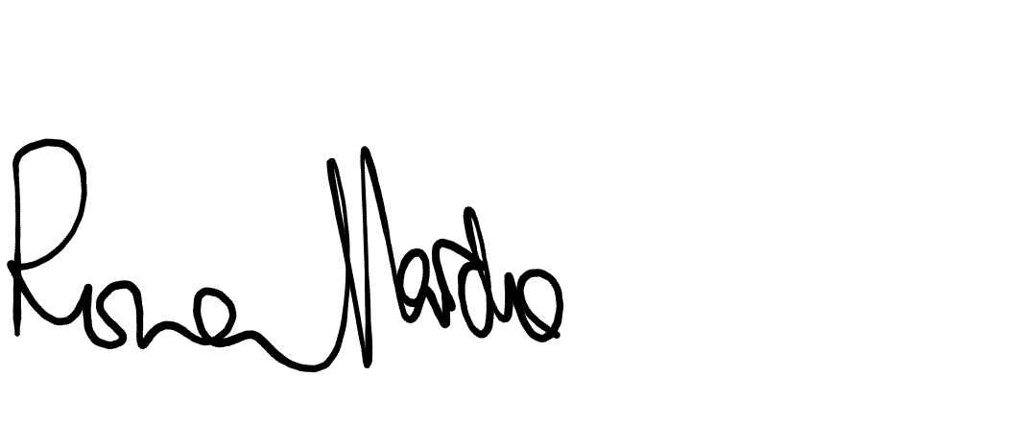

Date: 30/06/23

Short statement giving reasons for wishing to participate in FoES Board and skills and expertise that the candidate will bring:

I’ve been involved in Young Friends of the Earth Scotland since 2019, including 2 years on the steering group. During that time I’ve been involved in several campaigns and pieces of work, including delivering trainings and working on the Campaign for a Just & Green Recovery.

Additionally, I work for Tipping Point UK as a Stop Rosebank Organiser, and previously as the Scotland National Organiser. As part of this role I’ve worked with FoES in several different capacities, including organising a series of post-COP26 regional gatherings and on the Stop Rosebank Campaign. My role is currently focussed on developing training and development opportunities for the Stop Rosebank campaign.

I’m particularly interested in internal culture and organisation. As part of my role on the Tipping Point UK People & Culture team I’ve contributed to and led on pieces of work including Anti-Oppression processes, conflict mediation training, and the implementation of a peer support system, among others.

